INTRODUCTION:
Encryption of the data is being used in many data processing areas. A lot of encryption algorithms have been developed for processing of data If we are able to join the advantages of the many existing encryption methods, then a new hybrid encryption method can be developed which offers better security and protection.
So, in order to accomplish the Hybrid encryption technique,we are using data encryption techniques using Fibonacci series and other substitution techniques are studied and analyzed.
We use layered encryption approach in this where the first layer is encrypted using a substitution technique and second layer is encrypted using Fibonacci series and when it comes to decryption we first apply the Fibonacci series as first layer and then apply the substitution technique in second layer to finally obtain the plain text.
we used layered approach because if the attacker breaks one layer of the cipher text then he would still get a cipher text so if attacker wants to break the cipher text he needs to know how the encryption process works in the process of encryption we use a key in the first layer which is randomly generated each time the key works as a one time pad and in the second layer of encryption the key also get encrypted with the first layer of cipher text then the output of the second layer will be the cipher text formed with the combination of key and first layer cipher text since the key also gets encrypted it is difficult for the crypt analyst to break the cipher
As the substitution technique we use the caeser cipher where we substitute the given alphabtes and special symbols with other letters and symbols we do this operation with the help of key that is randomly generated and in the second layer the fibonacci series encryption takes place where we generate the fibonacci series and we transpose the letters according to the fibonacci number that is generated this is simple the hybrid cipher

Free and Open source software:
“Free software” means software that respects users' freedom and community. Roughly, it means that the users have the freedom to run, copy, distribute, study, change and improve the software. Thus, “free software” is a matter of liberty, not price. To understand the concept, you should think of “free” as in “free speech,” not as in “free beer”. We sometimes call it “libre software,” borrowing the French or Spanish word for “free” as in freedom, to show we do not mean the software is gratis.
We campaign for these freedoms because everyone deserves them. With these freedoms, the users (both individually and collectively) control the program and what it does for them. When users don't control the program, we call it a “nonfree” or “proprietary” program. The non free program controls the users, and the developer controls the program;

The four essential freedoms
A program is free software if the program's users have the four essential freedoms:
- The freedom to run the program as you wish, for any purpose (freedom 0).
- The freedom to study how the program works, and change it so it does your computing as you wish (freedom 1). Access to the source code is a precondition for this.
- The freedom to redistribute copies so you can help your neighbor (freedom 2).
- The freedom to distribute copies of your modified versions to others (freedom 3). By doing this you can give the whole community a chance to benefit from your changes. Access to the source code is a precondition for this.

2.METHODOLOGY:
Encryption:

It consists of two layers:
- Caeser cipher encryption with key
- Fibonacci series encryption

1.First layer:

- we randomly generate a Random key which is used for the encryption of plain text
- The length of the key is calculated
- The key that is generated is added to the plain text substituting the plain text characters with other characters giving us the cipher text
- Now we append the key to the cipher text at the end
- This is the output that is obtained in the first layer with the help of caeser cipher and a key

2.Second layer:

- The length of the output of first layer is calculated first
- According to the length of the key that is calculated in first layer of encryption we generate the fibonacci series
- Then we transpose each letter according to the fibonacci number
- The odd number places are stepped up the number of times of the fibonacci number.
- The even number places are stepped down the number of times of the fibonacci number.
- Then we after this we finally obtain the cipher text with the key padded and encrypted
- the length of the that was padded is also appended to the obtained cipher text for the decryption algorithm to decrypt
- this obtained cipher text is sent as a message and is decrypted at the receivers end

Decryption:

It consists of two layers:
- Fibonacci series decryption
- Caeser cipher decryption with key obtained from cipher text.

1.First layer:

- we remove the length of the key that was padded to the obtained cipher text
- then according to the length of the key we generate the fibonacci series
- Now we transpose each letter in reverse method of encryption
- The odd number places are stepped down the number of times of the fibonacci number.
- The even number places are stepped up the number of times of the fibonacci number.
- Then form the output we remove the key that was padded with the first layer of the cipher text
- this is the output of first layer

2.Second layer:

- Now we simply use the key and subtract the cipher text that is obtained in the first layer of decryption
- then the letters are substituted back to the original place and the plain text is obtained

3.CODE:
Encryption.py:

import random

#assign values to every character

values={0: 'a', 1: 'b', 2: 'c', 3: 'd', 4: 'e', 5: 'f', 6: 'g', 7: 'h', 8: 'i', 9: 'j', 10: 'k', 11: 'l', 12: 'm', 13: 'n', 14: 'o', 15: 'p', 16: 'q', 17: 'r', 18: 's', 19: 't', 20: 'u', 21: 'v', 22: 'w', 23: 'x', 24: 'y', 25: 'z', 26: 'A', 27: 'B', 28: 'C', 29: 'D', 30: 'E', 31: 'F', 32: 'G', 33: 'H', 34: 'I', 35: 'J', 36: 'K', 37: 'L', 38: 'M', 39: 'N', 40: 'O', 41: 'P', 42: 'Q', 43: 'R', 44: 'S', 45: 'T', 46: 'U', 47: 'V', 48: 'W', 49: 'X', 50: 'Y', 51: 'Z', 52: '1', 53: '2', 54: '3', 55: '4', 56: '5', 57: '6', 58: '7', 59: '8', 60: '9', 61: '0', 62: '!', 63: '@', 64: '#', 65: '$', 66: '%', 67: '^', 68: '&', 69: '*', 70: '(', 71: ')', 72: '-', 73: '_', 74: '=', 75: '+', 76: '[', 77: ']', 78: '{', 79: '}', 80: ';', 81: ':', 82: "'", 83: '"', 84: '|', 85: ',', 86: '.', 87: '/', 88: '<', 89: '>', 90: '?', 91: '~', 92: '`', 93: ' '}

values1={'a': 0, 'b': 1, 'c': 2, 'd': 3, 'e': 4, 'f': 5, 'g': 6, 'h': 7, 'i': 8, 'j': 9, 'k': 10, 'l': 11, 'm': 12, 'n': 13, 'o': 14, 'p': 15, 'q': 16, 'r': 17, 's': 18, 't': 19, 'u': 20, 'v': 21, 'w': 22, 'x': 23, 'y': 24, 'z': 25, 'A': 26, 'B': 27, 'C': 28, 'D': 29, 'E': 30, 'F': 31, 'G': 32, 'H': 33, 'I': 34, 'J': 35, 'K': 36, 'L': 37, 'M': 38, 'N': 39, 'O': 40, 'P': 41, 'Q': 42, 'R': 43, 'S': 44, 'T': 45, 'U': 46, 'V': 47, 'W': 48, 'X': 49, 'Y': 50, 'Z': 51, '1': 52, '2': 53, '3': 54, '4': 55, '5': 56, '6': 57, '7': 58, '8': 59, '9': 60, '0': 61, '!': 62, '@': 63, '#': 64, '$': 65, '%': 66, '^': 67, '&': 68, '*': 69, '(': 70, ')': 71, '-': 72, '_': 73, '=': 74, '+': 75, '[': 76, ']': 77, '{': 78, '}': 79, ';': 80, ':': 81, "'": 82, '"': 83, '|': 84, ',': 85, '.': 86, '/': 87, '<': 88, '>': 89, '?': 90, '~': 91, '`': 92, ' ': 93}

message=input("just enter message : ") #input of message to encrypt

k=len(message)//2 #calculating the k value to generate random key

keylength=random.randrange(k,len(message)) #Generating the keylegth randomly
alphaascii,key=list(range(94)),[]
for i in range(keylength):
random.shuffle(alphaascii)
key.append(values[alphaascii[0]]) #generating random key of k charecteres
#print("key is : ",end='') #printing the key
#print(key)
#print("key length is %d "%(keylength)) #printing the key length
j,cipher1=len(key)-1,[]
for i in range(len(message)): #performing substitution operation with reverse key
if(j==-1):
j=len(key)-1
cipher1.append(values[((values1[message[i]]-values1[key[j]])%94)])
j-=1
cipher1=cipher1+key #concatinating the message and key
#print("Cipher text after XOR : ",end='')
#print("".join(cipher1))
a,b,j=1,1,11
while(j): #performing Fibonacci series
for i in range(len(cipher1)):
if(i%2==0):
num=values1[cipher1[i]]+a
if(num>93):
num=num-94
else:
num=values1[cipher1[i]]-a
if(num<0):
num=num+94
cipher1[i]=values[num]
a,b=b,a+b
j-=1
keysize=len(str(keylength))
cipher1.append(str(keylength))
cipher1.append(values[keysize])
print("\nFinal Cipher message is : ",end='')
print("".join(cipher1)) #final cipher message

Decryption.py:

#assign values to every character

values={0: 'a', 1: 'b', 2: 'c', 3: 'd', 4: 'e', 5: 'f', 6: 'g', 7: 'h', 8: 'i', 9: 'j', 10: 'k', 11: 'l', 12: 'm', 13: 'n', 14: 'o', 15: 'p', 16: 'q', 17: 'r', 18: 's', 19: 't', 20: 'u', 21: 'v', 22: 'w', 23: 'x', 24: 'y', 25: 'z', 26: 'A', 27: 'B', 28: 'C', 29: 'D', 30: 'E', 31: 'F', 32: 'G', 33: 'H', 34: 'I', 35: 'J', 36: 'K', 37: 'L', 38: 'M', 39: 'N', 40: 'O', 41: 'P', 42: 'Q', 43: 'R', 44: 'S', 45: 'T', 46: 'U', 47: 'V', 48: 'W', 49: 'X', 50: 'Y', 51: 'Z', 52: '1', 53: '2', 54: '3', 55: '4', 56: '5', 57: '6', 58: '7', 59: '8', 60: '9', 61: '0', 62: '!', 63: '@', 64: '#', 65: '$', 66: '%', 67: '^', 68: '&', 69: '*', 70: '(', 71: ')', 72: '-', 73: '_', 74: '=', 75: '+', 76: '[', 77: ']', 78: '{', 79: '}', 80: ';', 81: ':', 82: "'", 83: '"', 84: '|', 85: ',', 86: '.', 87: '/', 88: '<', 89: '>', 90: '?', 91: '~', 92: '`', 93: ' '}

values1={'a': 0, 'b': 1, 'c': 2, 'd': 3, 'e': 4, 'f': 5, 'g': 6, 'h': 7, 'i': 8, 'j': 9, 'k': 10, 'l': 11, 'm': 12, 'n': 13, 'o': 14, 'p': 15, 'q': 16, 'r': 17, 's': 18, 't': 19, 'u': 20, 'v': 21, 'w': 22, 'x': 23, 'y': 24, 'z': 25, 'A': 26, 'B': 27, 'C': 28, 'D': 29, 'E': 30, 'F': 31, 'G': 32, 'H': 33, 'I': 34, 'J': 35, 'K': 36, 'L': 37, 'M': 38, 'N': 39, 'O': 40, 'P': 41, 'Q': 42, 'R': 43, 'S': 44, 'T': 45, 'U': 46, 'V': 47, 'W': 48, 'X': 49, 'Y': 50, 'Z': 51, '1': 52, '2': 53, '3': 54, '4': 55, '5': 56, '6': 57, '7': 58, '8': 59, '9': 60, '0': 61, '!': 62, '@': 63, '#': 64, '$': 65, '%': 66, '^': 67, '&': 68, '*': 69, '(': 70, ')': 71, '-': 72, '_': 73, '=': 74, '+': 75, '[': 76, ']': 77, '{': 78, '}': 79, ';': 80, ':': 81, "'": 82, '"': 83, '|': 84, ',': 85, '.': 86, '/': 87, '<': 88, '>': 89, '?': 90, '~': 91, '`': 92, ' ': 93}

message=input("enter message to decrypt : ")
decrypt=[x for x in message]
keylength=decrypt[-1]
del decrypt[-1]
keysize=len(decrypt)-values1[keylength]
keysize1=decrypt[keysize:]
del decrypt[keysize:]
print(keysize1)
a,b,j=1,1,11
while(j): #performing fibonacci series
for i in range(len(decrypt)):
if(i%2==0):
num=values1[decrypt[i]]-a
if(num<0):
num=num+94
else:
num=values1[decrypt[i]]+a
if(num>93):
num=num-94
decrypt[i]=values[num]
a,b=b,a+b
j-=1
#print("Decrypted message after Fibonacci series : ",end='')
#print("".join(decrypt))
k=int("".join(keysize1))
key=decrypt[len(decrypt)-k:]
del decrypt[len(decrypt)-k:]
j,decrypt1=len(key)-1,[]
for i in range(len(decrypt)): #performing the substitution operation
if(j==-1):
j=len(key)-1
decrypt1.append(values[((values1[key[j]]+values1[decrypt[i]])%94)])
j-=1
print("final plane text is : ",end='')
print("".join(decrypt1)) #final plane text

Outputs:
Encryption:
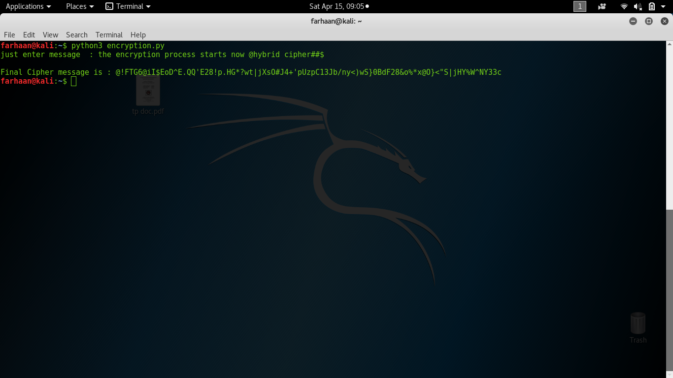

Encryption with special symbols :
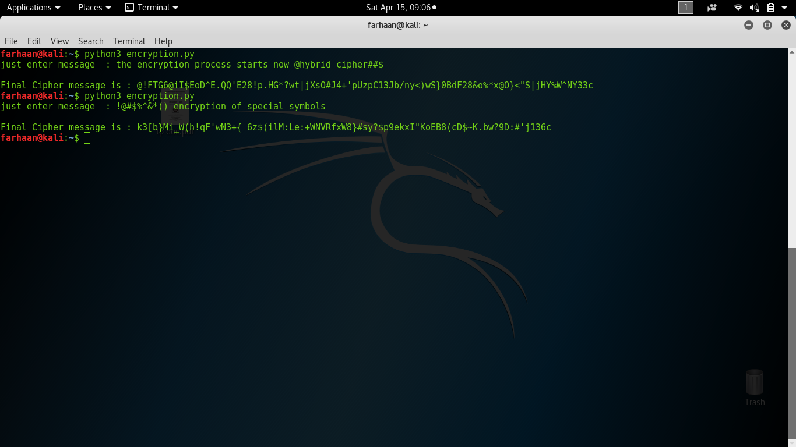
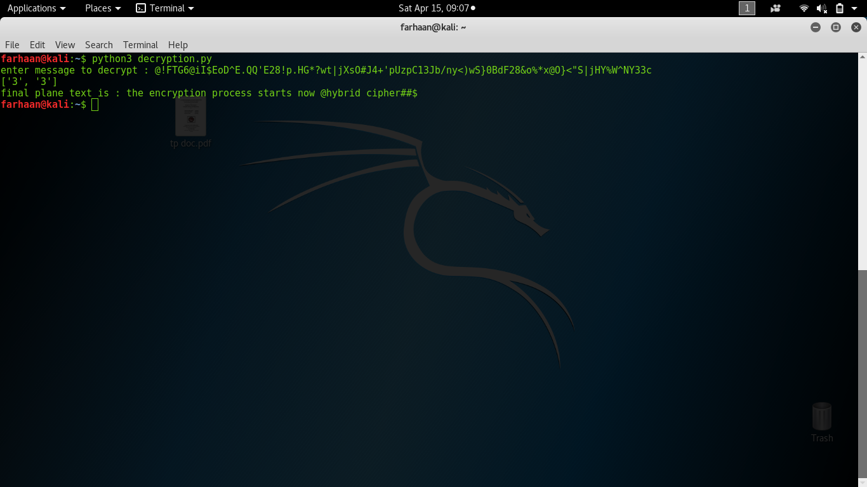
Decryption:
Encryption of same plain text but the obtained plain text each time is Unique:
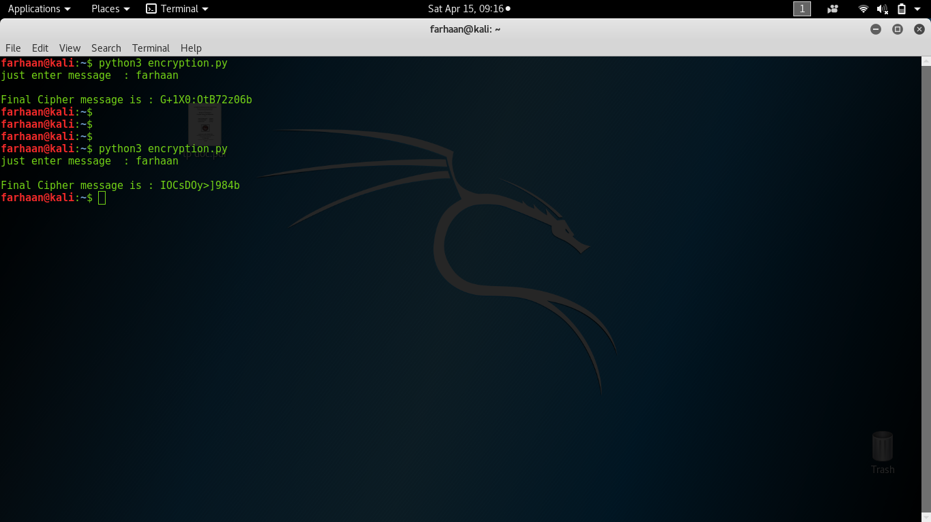
Decryption of the cipher texts that were obtained uniquely each time:
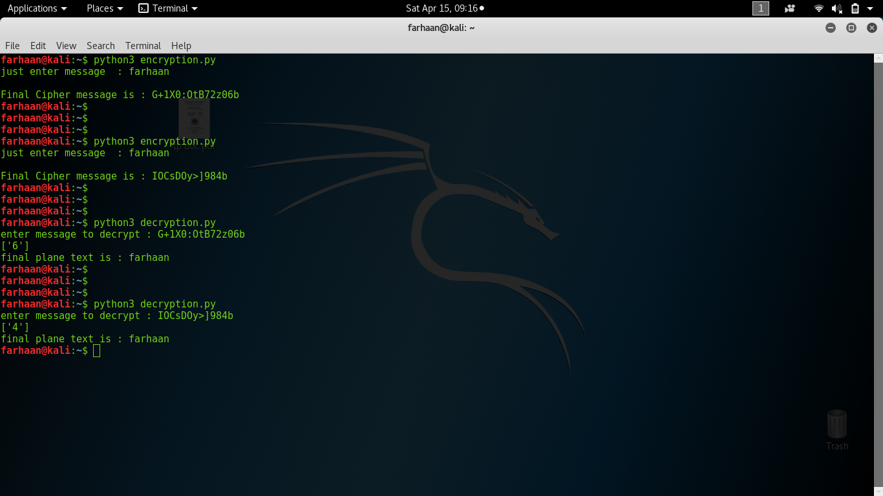
ADVANTAGES:
1. We generate a random key of random size each time.
2.The key gets appended to the plain text and is also gets encrypted using the Fibonacci series
3.Since it follows layered approach even if one layer is decrypted the cryptanalyst would still get cipher text
4.Even if same plain text is used the cipher text obtained is different as we use the random key each time, By this chosen plain text attack cannot be possible.
5.we can also avoid buffer over flow problems

CONCLUSION:
In the study of the hybrid cipher for data encryption we studied the advantages of the layered encryption approach and the common types of the security attacks such as choosen plain text attack and brute force attack are not applicable to such ciphers
the key we generated in the above study is randomly generated and works as a one time pad so it is difficult for the crypt analyst to identify the key.
Many more layers of encryption techniques can be added which may or may not use keys by this the efficiency of the algorithm may decrease and many other security attacks are possible so we limited the number of layers to two and prevented the common types of the security attacks that are possible .

